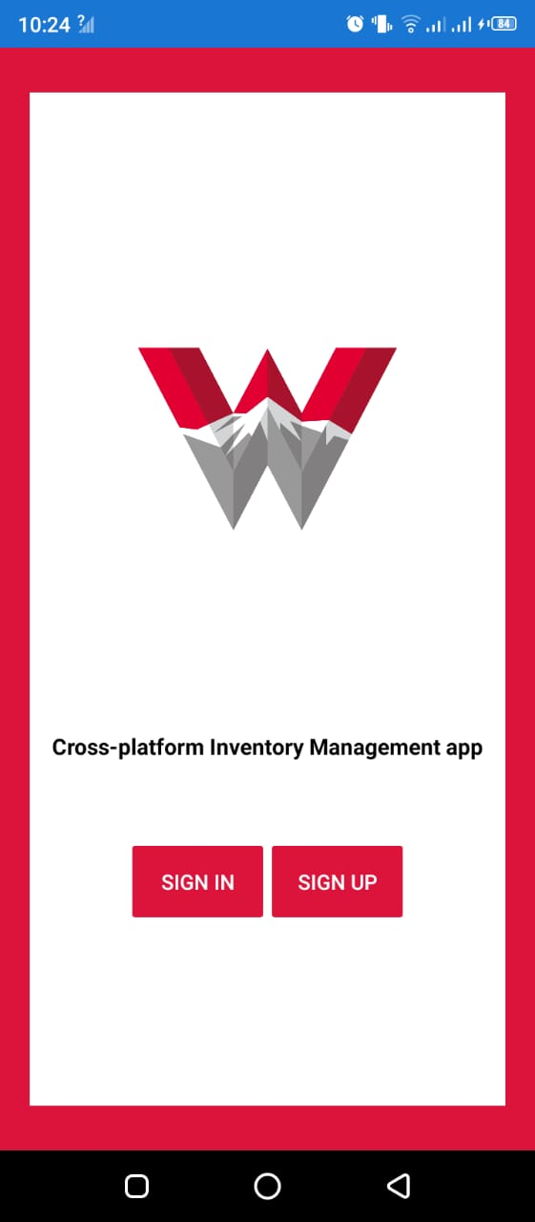

Inventory Manager

Agile Project Report

Name | Course Title | Date

# Introduction

As the name itself suggests, this project is an attempt to manage the inventory in a more efficient and manageable way. Sometime we can’t remember where our stock goes. And we can’t handle our flow of the stocks in the inventory this app will help in doing so.

For this problem, we need a solution that one can manage their stock. So, we decided to find an easier way to get rid of this problem. So, our application attempts to free the user with as much as possible the burden of manual calculation and to keep the track of the stocks.

Instead of keeping a diary or a log of the stocks, this application enables the user to not just keep the control on the stocks but also to generate and save reports of the weekly and monthly stocks. With the help of this application, the user can manage their stocks in the inventory on a daily, weekly and monthly basis. Users can insert and delete stock in the inventory as well as can generate and save their reports.

The graphical representation of the application is the main part of the system as it appeals to the user more and is easy to understand because of its simplicity.

# Literature Review:

## What is Xamarin?

Xamarin is an open-source platform for building modern and performant applications for iOS, Android, and Windows with .NET. Xamarin is an abstraction layer that manages communication of shared code with underlying platform code. Xamarin runs in a managed environment that provides conveniences such as memory allocation and garbage collection.

Xamarin enables developers to share an average of 90% of their application across platforms. This pattern allows developers to write all of their business logic in a single language (or reuse existing application code) but achieve native performance, look, and feel on each platform.

Xamarin applications can be written on PC or Mac and compile into native application packages, such as an **.apk** file on Android, or an **.ipa** file on iOS.

## Who Xamarin is for?

Xamarin is for developers with the following goals:

* Share code, test and business logic across platforms.
* Write cross-platform applications in C# with Visual Studio.

## How xamArin works?

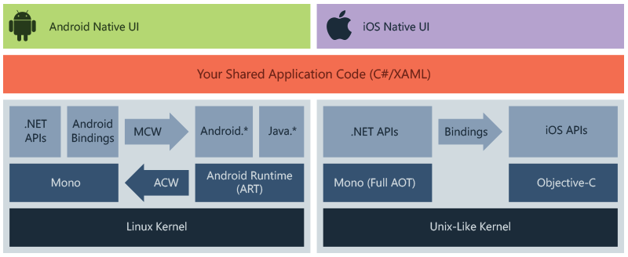

Figure 1 Working of the Xamrine

The diagram shows the overall architecture of a cross-platform Xamarin application. Xamarin allows you to create native UI on each platform and write business logic in C# that is shared across platforms. In most cases, 80% of application code is sharable using Xamarin.

Xamarin is built on top of .NET, which automatically handles tasks such as memory allocation, garbage collection and interoperability with underlying platforms.

## What is Agile SDLC?

Agile SDLC model is a combination of iterative and incremental process models with focus on process adaptability and customer satisfaction by rapid delivery of working software product. Agile Methods break the product into small incremental builds. These builds are provided in iterations.

The Steps that are followed by the Agile SDLC are stated as follows:

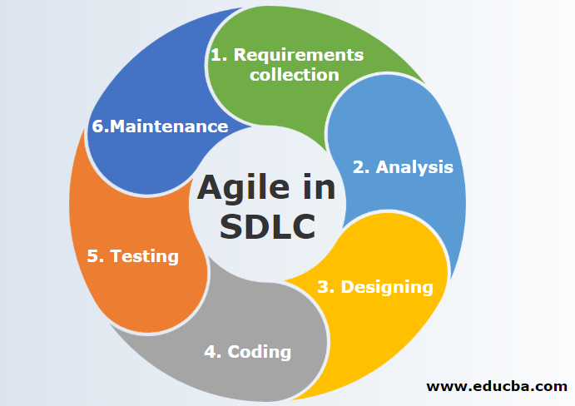

Figure 2 Steps for the Agile SDLC

# Tools and Technology Requirement:

**Hardware Requirements:**

**Processor**

Intel ® Core™ i3-2370 CPU @2.40GHz

**Installed Memory (RAM)**

1.00 GB or above

**Software Requirements:**

Android 4.4 Kitkat or above.

IOS 9 above

**Software Interface**

Client-Side

Android Mobile

**Development Software:**

Xamarin

# Modules of the Application:

The modules which are currently covered are:

**Sign up/Login:**

The module is responsible for the sign up a new user in the application so that the user can use the application. For the sake of the Signing up the user have to press the sign-up button on the main screen than a new page will appear where the user will enter the “username”, “password”, “confirm password”, “first name”, “last name” and “account type”. If the user is a previously registered user, then the user has to press the Login button on the main screen and enter the username and password of the user and the application will ready to go and will take the user to the main menu.

**Modify Inventory Products:**

If the user wants to delete any inventory product, then the user has to click the product in the inventory that is available in the inventory list then press the delete button in the navigation bar and the product will be deleted from the inventory.

**Filter Product view:**

In the search tab, the user can filter the product. The user can just enter the name of the product or the type of the product in the search bar and all the products will be filtered and only the products related to the keyword that is entered to the search bar will appear in the inventory list.

**Add inventory Products:**

If the user wants to add any inventory product, then the user has to click the + product in the navigation menu bar then a new page will open here you have to enter the product name, price of the product and can add the product image URL then the product will be added into the inventory.

**Multiple Accounts**

Users can create multiple accounts. In the account tab. User has the option available for creating a new account.  Users will click the “+” sign button then a dialog will appear on the screen and the user can enter the name of the account then that name will be saved in the account tab. If a user wants to delete the particular account, then the user has to l click the account name user want to delete. Then that account will be deleted.

# Sequence Diagram:

The sequence diagram for the Inventory Management application is stated as follows:

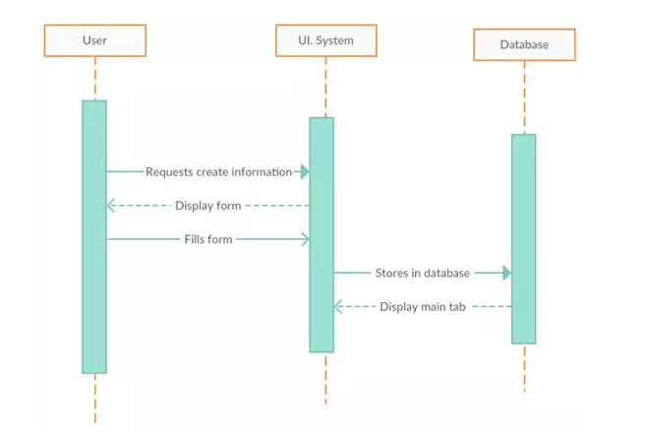

Figure 3 Sequence Diagram for the Inventory Management Application

User is now creating information inside the application selecting the option for the inventory stocks to be added which will then displays the form to be filled to added the inventory item. And store the inventory item in the database that then can be displayed in the inventory list inside the application.

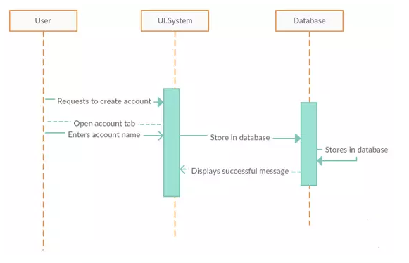

Figure 4 Sequence Diagram for the Inventory Management Application

The above stated sequence diagram shows that how a new user can create account in the inventory management application for the sake of management of the inventory stocks.

# Working of the Inventory Management Application:



Figure 5 Main Page of the Inventory Management Application

Here by opening the inventory management application this page will open up here the user can sign in if he/she is a previous user otherwise the user has to press the sign-up button and enter the details and then sign in.

**Sign up:**

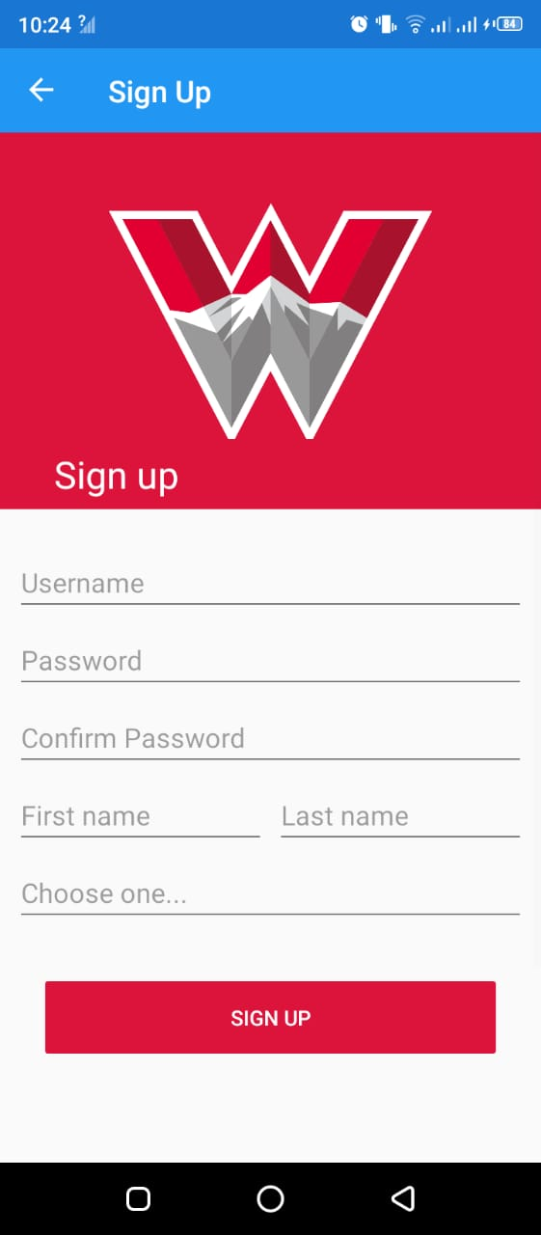

Figure 6 Sign up interface

The module is responsible for the sign up a new user in the application so that the user can use the application. For the sake of the Signing up the user have to press the sign-up button on the main screen than a new page will appear where the user will enter the “username”, “password”, “confirm password”, “first name”, “last name” and “account type”.

**Sign in:**

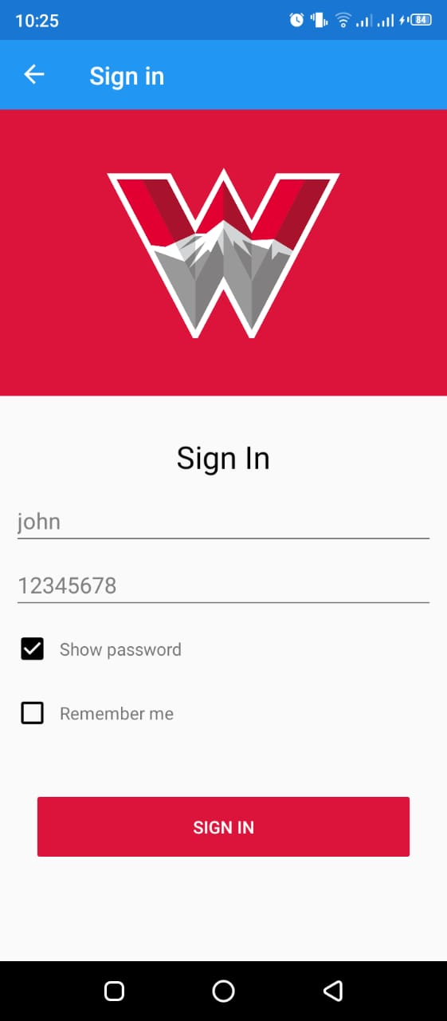

Figure 7 Sign in interface

If the user is a previously registered user, then the user has to press the Login button on the main screen and enter the username and password of the user and the application will ready to go and will take the user to the main menu.

**Add inventory Products:**

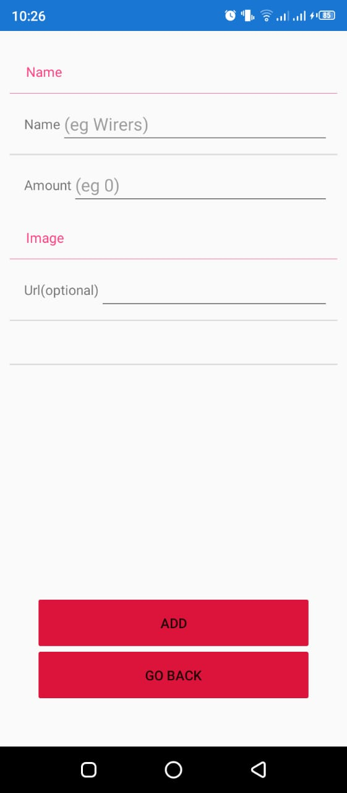

Figure 8 Add Inventory form interface

If the user wants to add any inventory product, then the user has to click the + product in the navigation menu bar then a new page will open here you have to enter the product name, price of the product and can add the product image URL then the product will be added into the inventory.

**Search bar and Inventory List:**

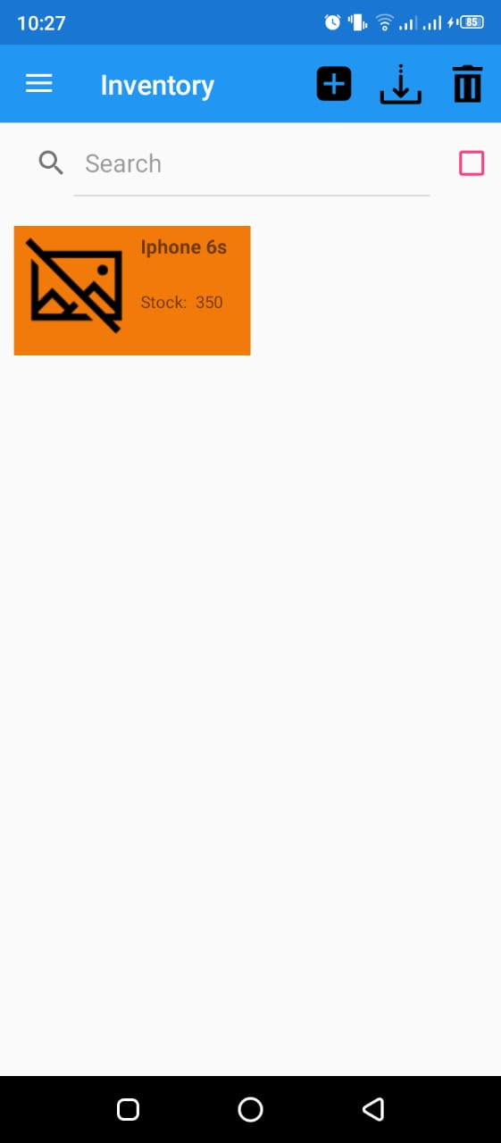

Figure 9 Search bar and Inventory list interface

In the search tab, the user can filter the product. The user can just enter the name of the product or the type of the product in the search bar and all the products will be filtered and only the products related to the keyword that is entered to the search bar will appear in the inventory list.

**Account Details:**

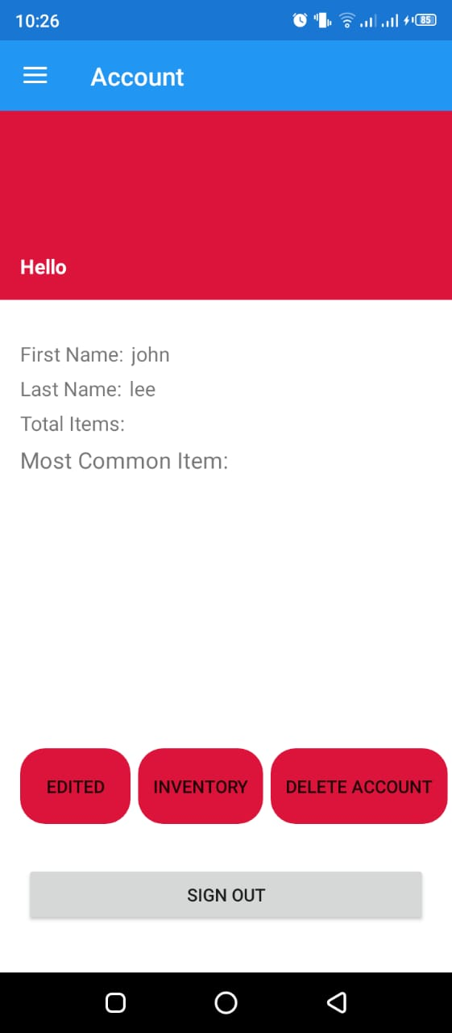

Figure 10 Account Details interface

Details of the account owner can be seen in this module.

**Delete Inventory Stock:**



Figure 11 Delete inventory interface

Selecting the inventory item in the list then pressing the delete icon in the navigation bar will delete the product from the inventory list.

# Group Tasks:

## Student 1:

The first student has done the designing of the application interface and the functionality to add the inventory using the application and designed the add inventory stock form.

## Student 2:

The second student has implemented the functionality of search inventory in the application for the sake of filtering and helped the student 1 in designing the application interface.

## Student 3:

The student 3 has implemented the Sign up and Sign in and designed their request forms.

## Student 2 and 3:

Student 2 has helped the student 3 in these modules and implemented delete button functionality to delete stock from the inventory.

## Student 1:

Student 1 has implemented and managed the database for the application for the effective management and storing of the data of the application.